6.7.1 Search activity - You know there’s a patent in country A covering your product, but are you free to market it in country B?
Your company wants to manufacture a low cost miniature camera with a reduced number of parts. There is a Japanese patent application JP11212162A for a similar camera. Are they free to operate in the United States?

Where do you start? Firstly, it is necessary to check the format of the Japanese document at http://www.epo.org/searching/asian/japan/numbering.html. From this we find that the number has to include an extra H, and now reads JPH11212162.

Step | Description of step | Model answer
1 | Find out whether JPH11212162 has any family members for a miniature camera. | Go to Espacenet and look for JPH11212162 under publication number.  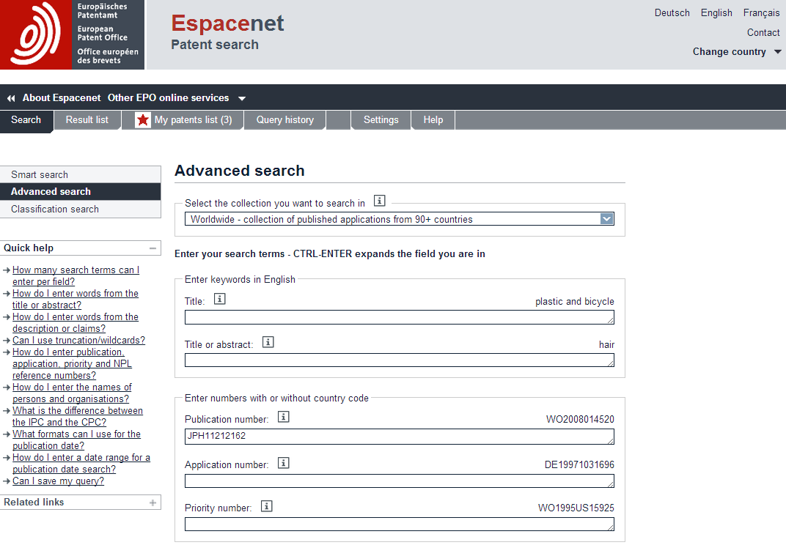  Click the title, Click INPADOC patent family.  This shows a patent family of 15 members.
2 | Did you see any US documents? | From the patent family list in Espace, we can see US patents US6278846 and US6554497.
3 | What is their status? | Go to http://portal.uspto.gov/external/portal/pair  Type in the two check words as requested. Choose Patent Number and type in 6278846. Click search. This shows that the patent expired due to non-payment of maintenance fees.  Check the other publication number. What result do get

